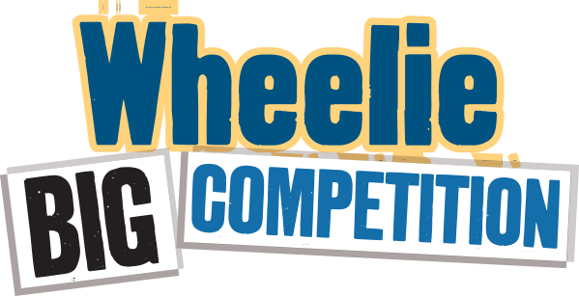
Entry 2017-18
Submit a brief description below of the actions you took at school and at home to improve recycling and reduce waste. No more than 200 words in total – don’t forget to mention food waste actions! Include any waste audit information you have. You may include up to 3 photos with your written answer.

At school (150 words):

At home (50 words):

Submit your entry by email to cathy.gorman@keepnorthernirelandbeautiful.org or by post to Eco-Schools, Bridge House, 2 Paulette Avenue, Belfast, BT5 4HD. Clearly mark which school the entry is from in your email or posted entry.
Shortlisted schools will be invited to Belfast City Hall on Thurs 17th May to present their Wheelie Big Challenge results in a colourful display stand for judging.
Closing date for entries is Wed 25th April 2018.
Prizes for both Primary and Post-Primary are - First Place - £500
Second Place - £300
Third Place- £200

