“POETREE”
Write your own acrostic about nature. 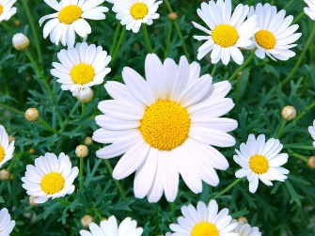

N
A
T
U
R
E

T
R S
E U
E N

F
L
O B
W I
E R
R D

F
L
O
W
E
R
S

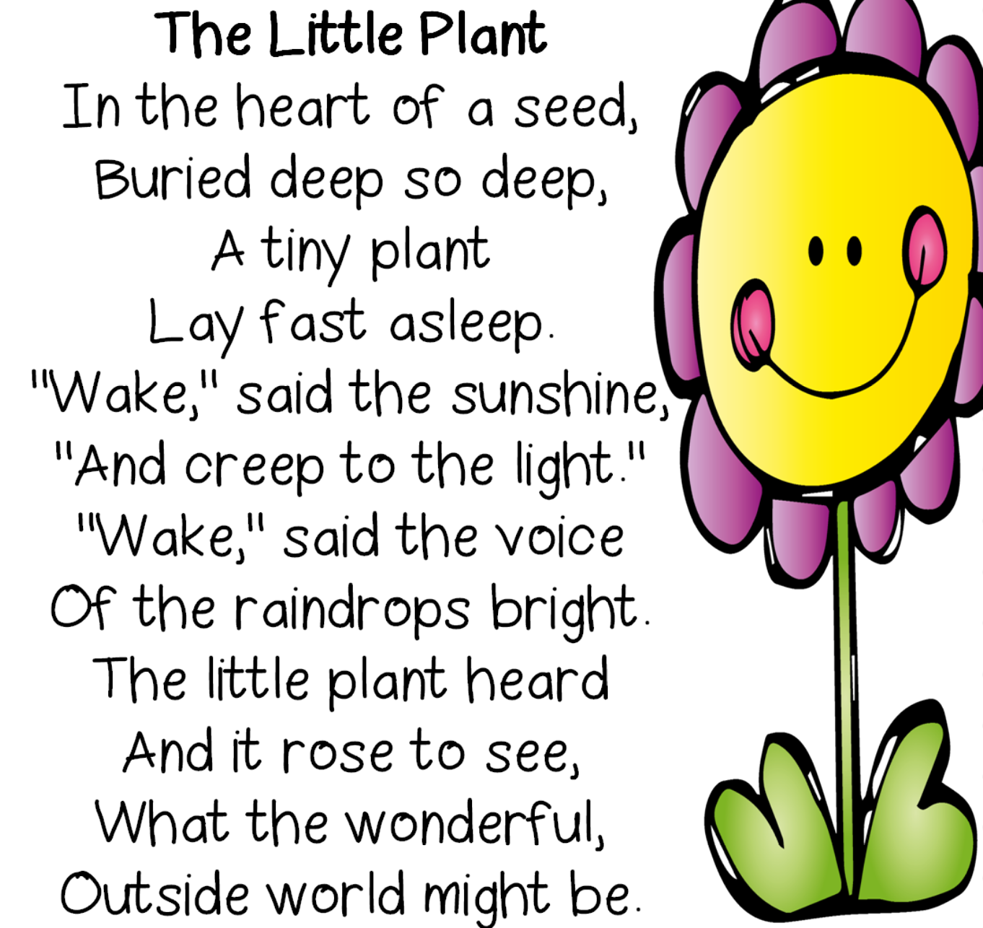

Write a poem based on nature. What do you see, smell, hear and feel?

