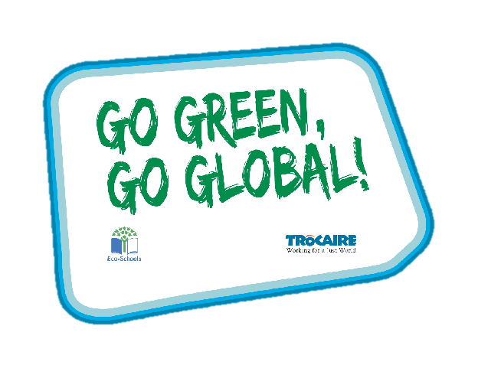
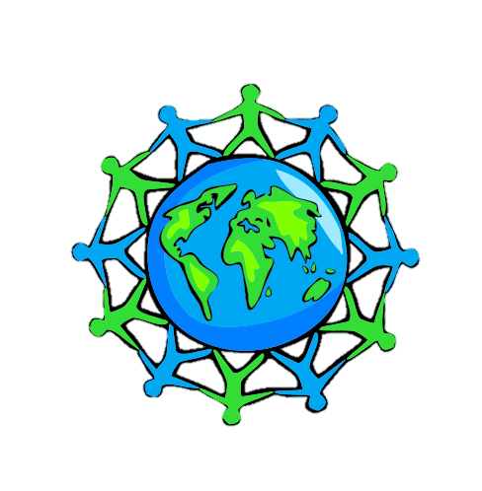
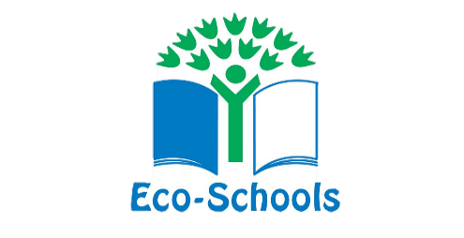

Global Perspective
Water
Climate Change

Key Stage 2

‘Whole Class Activity’ Resource Booklet
The purpose of this resource
The Eco-Schools programme in Northern Ireland is operated by Keep Northern Ireland Beautiful and addresses the following eleven topics within schools:
Biodiversity Energy Global Perspective Healthy Living
Litter Marine Transport Waste
Water Climate Change School Grounds (outdoor learning)
In order to qualify for the much acclaimed 'Green Flag' award level, schools must have shown substantial progress towards completing 'one large scale project topic and indicated involvement with two others'.
Through the expertise of the Irish development agency Trocaire, this resource provides a range of activities to incorporate a global perspective into the classroom. It will focus on three of the eleven Eco-School topics and will explain how to introduce and explore these global issues with your pupils.
Each section contains an information sheet on the global issue and one whole class activity.
Content
Section 1 – Global Perspective 3-13
Section 2 – Water 14-16
Section 3 – Climate Change 17-18

Section 1: Global Perspective
Background information
Being a global citizen is not clearly defined. As there is no global government there are no clear rules and regulations and globally, we do not have democratically elected representatives to speak for us.
Global citizenship is more a moral understanding of our responsibilities and our rights in a global context. Being a true global citizen means that we recognise that all people have equal rights and value diversity.
In addition, it means we should value planet earth as our common home and one which we all have a need and indeed a responsibility, to look after.
Exercise 1: A day in the life of...
Aim:
Material needed: Worksheet
Step 1: Complete the worksheet ‘A day in the life of’ about your life…
Step 2: Have some of the pupils read out their work. Explain to them that they are now going to watch a video about a girl named Patricia who lives in Malawi. Ask them to see if they can spot any differences or similarities in her day and theirs.
Step 3: The teacher will read the text aloud for those children unable to do so. Play the video a second time, this time pausing and writing up details about the chores that Patricia must complete before school.
Step 4: Using the prompts on the board complete ‘A day in the life of Patricia’.
Video link: PowerPoint

On a school day I wake up at…
I usually wear…
I travel to school by…
Before I go to school, I must…
For lunch I eat things like…
My school building has…
When I get home from school, I like to…
My home looks like this…

A Day in the Life of…

On a school day Patricia wakes up at…
Patricia usually wears …
Patricia travels to school …
Before I go to school, I must…
For lunch Patricia eats things like …
Patricia’s school building has…
When Patricia gets home from school she…
Patricia’s home looks like this…

A Day in the Life of Patricia from Malawi

Background: Global Environment
The term environment means surroundings or the natural world. However, it can be narrowly defined. For example, our immediate surroundings as in the classroom environment or very broadly, in relation to the global environment.
One thing that is certain is that humankind has had a huge impact on the environment. Today, many of us have acquired so many things that we have a very comfortable lifestyle. But at what cost?
The more that people take from the environment, the more they change the pattern of nature. If we take too much, we risk upsetting this balance.
The balance of nature changes slowly over time but in recent years we have wanted more and more for ourselves, and we are upsetting the balance at a faster rate, without even realising it.
We are part of the natural environment and must look after it. If we upset the pattern too much, we may even destroy ourselves and the lives of future generations.
Trócaire’s focus is on ensuring that our global resources are shared equitably and those in power act for the common good of all.

Exercise 2: Wants and Needs of living things
Aim: To understand the difference between a want and a need
Materials: Internet connection to play the video
Step 1: Watch the internet video as a class. (PowerPoint)

Step 2: Thumbs up thumbs down or one side of the room is a want, and the other is a need.
Step 3: Discuss each want or need individually to ensure understanding.
Step 4: Explain many children/people get to have all these things (both their needs and wants) however some children even here in this classroom may not get all these things.
Step 5: Open a discussion around: Is it fair one person should get something while other person goes without?
Step 6: Family and love should be discussed – these are things we need to look after our emotional health.
Step 7: Cut out the different wants and needs and stick them into the correct half of the table e.g. Water is a need.

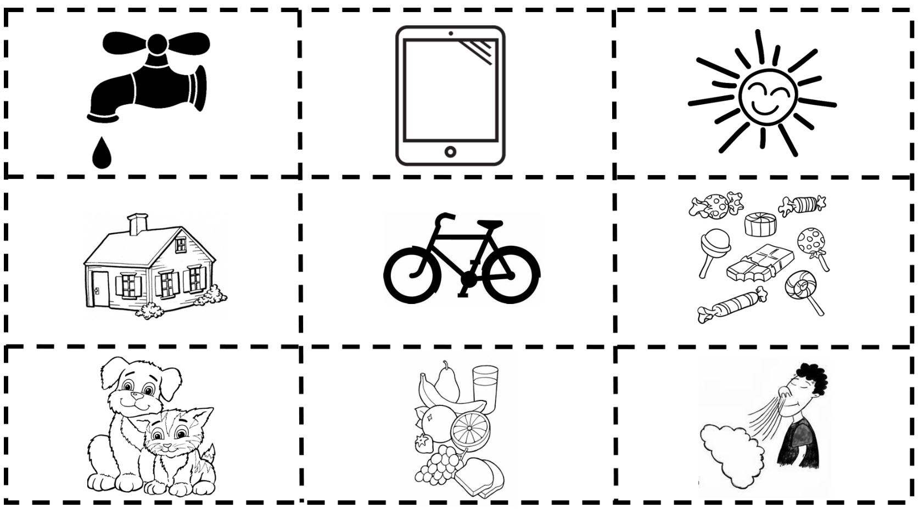

Exercise 3: Conserve and Protect our Natural Resources

Aim: to understand the importance of individual actions in protecting and conserving our natural resources

Materials: Internet connection to play the video

Step 1: Read the question to the young people and ensure they understand it (What are natural resources and how do we conserve them?)

Step 2: Watch the video (PowerPoint)

Step 3: Open up the discussion around how should we conserve and protect our natural resources.

Exercise 4: Natural or Humanmade

Aim: to be able to differentiate between a natural resource and a humanmade resource

Materials: copy of sheet, scissors, and glue.

Step 1: Identify all the items on the sheet and, based on the video, discuss if they are natural or human made.

Step 2: Cut and stick the correct picture into the correct half of the table

Step 3: Extension: colour in the worksheet

Natural or Humanmade
Natural | Humanmade

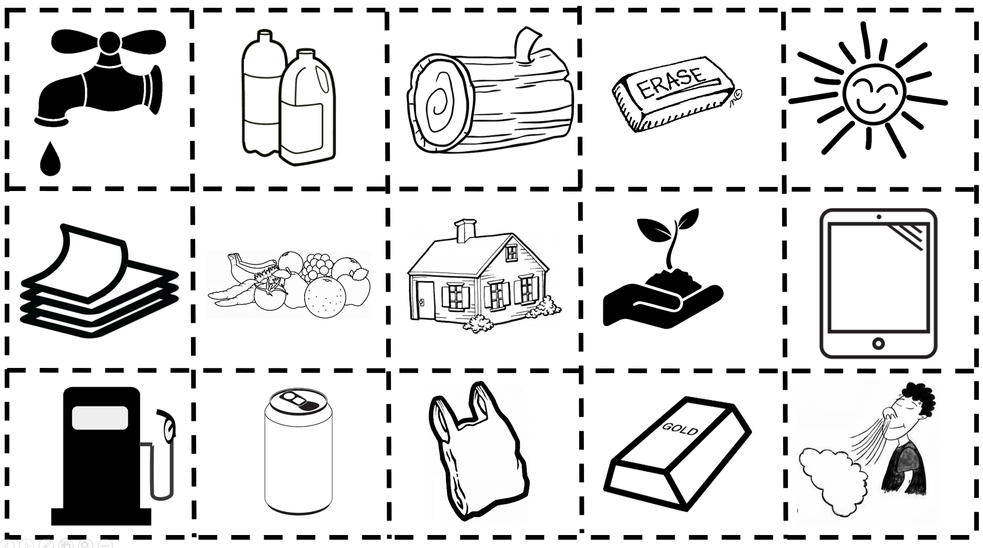

Background: Global Population

Our precious finite world is currently home to over 7.8 billion people. Numbers this big are difficult to understand but what if we imagined the whole population of the world as a village of just 100 people? In this imaginary village, each person would represent about 78 million people from the real world. One hundred people would fit nicely into a small village. By learning about the villagers – who they are and how they live – perhaps we can find out more about our neighbours in the real world and the problems our planet may face in the future.

Imagining the world as a village also makes it easier for us to start thinking about all the human and environmental problems in the world and what we can do to help solve them. It makes it easier for children to grasp the concept that the world is a large place, and many people in the world live lives much different from our own.

Exercise 5: If the world were 100 people

Aim: To grasp the concept that the world is a large place; and many people in the world live, lives much different from our own. To look at our relationship with the wider world.

Materials: Internet connection to play the video, photocopies of the worksheet and pens

Step 1: Watch the internet video as a class. (PowerPoint)

Step 2: Give pupils the worksheet and in pairs or small groups ask them to fill in the blanks. See below for correct answers.

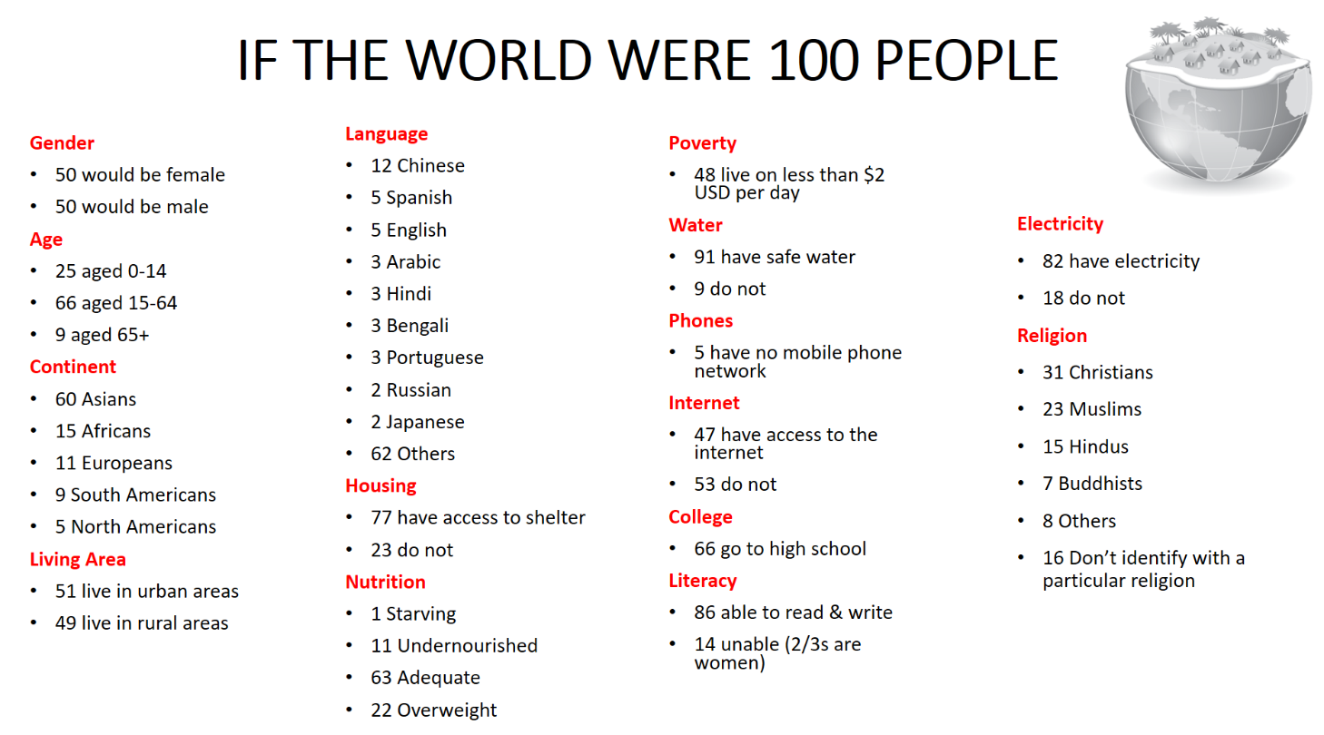
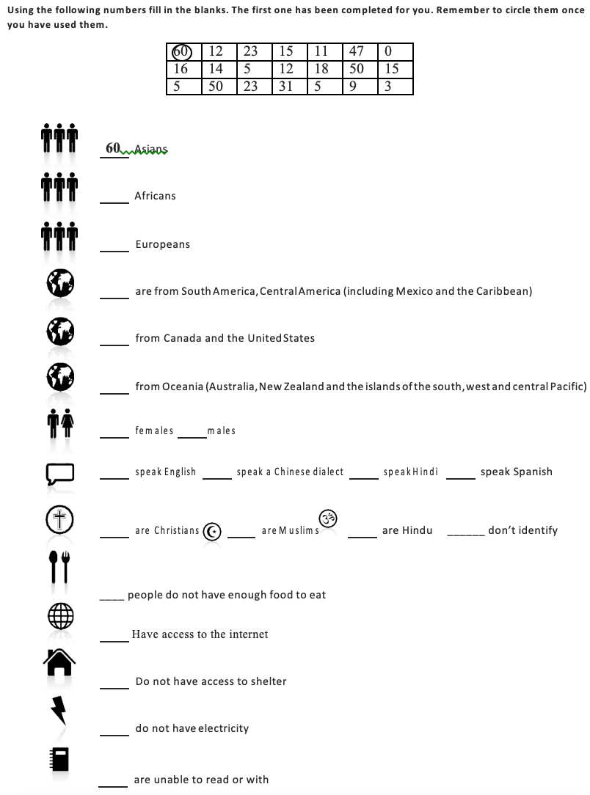
Exercise 5: Biscuit Game

Aim: To demonstrate how the world’s food is distributed and how injustice and inequality affect people’s lives.

Materials: Tables labeled with the numbers1 to 7, recycled plates and 30 biscuits (this game could also be played with pieces of Fairtrade bananas or chocolate).

Step 1: As children come into the classroom give each of them a number between 1 and 6 and ask them to sit at the table with that number. Each table has a plate of biscuits. Leave table 7 empty. Organise the biscuit, pupil ratio as indicated in the table below. Tell the children that they have two minutes to eat the biscuits. The teacher should watch and not interfere.

Table Number | Continent | Number of Biscuits | Number of Pupils for  a class of 30 | Number of Pupils for a class of 20
1 | Africa | 1 | 5 | 3
2 | Asia | 4 | 15 | 11
3 | Europe | 9 | 4 | 2
4 | Latin America | 1 | 3 | 2
5 | North America | 10 | 2 | 1
6 | Australia | 5 | 1 | 1
7 | Antarctica | 0 | 0 | 0

Step 2: After the children have finished eating, ask them the following:
- How did you feel when you saw how much other groups got?
- How did you divide the biscuits within your group?
- Did you do anything to get more biscuits, or did you give any away?
- How did you feel about eating a large/small amount?
- How did the other tables respond to you?
- Is this distribution fair? Why/why not? What would make it fair?
- What do you think the seven tables represent?

Step 3: Inform the children that the tables represent continents and display on a world map for them to see. Ask each group to talk among themselves and guess which continent they are. Each table should pin their table number on a world map to whichever continent they think they are. Reveal the correct continents.

Section 2: Water
Background information
Water is an essential natural resource in our everyday lives. While the amount on earth is always the same, the distribution of water across the world is not. Huge differences in rainfall can happen from country to country and even within the same country. Sometimes there just isn't enough water where it's most needed. As water is not evenly distributed across the globe, 1 in 10 people on earth live without basic access to clean water. The average person in North America uses a thousand times as much water as a person in Asia.

Exercise: Water in my world
Aim: To identify the different ways water features in our daily routine and understand how people around the world might have different experiences with water
Material needed: Case study of the live of Abasi
Step 1: Firstly, focus on your daily routine of water. Have a class discussion on all the times you use water throughout the day (morning to evening). Write this down on the whiteboard for the class to see. For example, shower/bath, drink water, toilet, cooking, watering plant.
Step 2: Read Abasi’s Story (Before Clean Water)
Step 3: Discuss how Abasi’s life is the same and different from yours (think about age, taking water for granted, missing school as a result of collecting water.
Step 4: Read Abasi’s story (After Clean Water)
Step 5: Discuss how gaining access to clean water changed his life.
Step 6: Explain to the children how privileged we are for are easy access to water and discuss ways to avoid wasting it.
Additional activity: Ask children to design an A4 sized poster, encouraging people not to waste water. The most effective can be placed around the school in places where people use water.

Abasi's Story: Before Clean Water
Abasi is 10 years old and lives in a small village in West Africa. He has two younger siblings. His sister Aluna is 8 and his brother Karmin is just 5 years old. Abasi's father is a farmer. Abasi's mother doesn't have time to do any paid work because she spends 4 hours every day walking several miles to the river to get water.
The people in Abasi's village don't have running water in their houses but get their water from the river. The water is brown and doesn't taste very good, but Abasi and his family have to drink it anyway because it's the only source of water they have. Sometimes the water makes Abasi's family sick.
When Abasi and his sister are sick, they miss school. Sometimes Aluna has to miss school because their mother is sick and so Aluna has to walk to get water. The water is so heavy though that it takes Aluna most of the day to bring it back from the river. If Abasi's father is sick, Abasi has to miss school to work in the fields. Karmin was sick a lot as a baby and as a young child. The bad water would give him diarrhoea. Abasi's family is really grateful that he is still alive, because a lot of children in his village die before they get to 5 years old from diarrhoea.
Abasi's family never seem to have enough money. Karim should start school this year, but the family can't afford the cost of the uniform or the books, so he still stays at home. Without money, the family can't pay for medicine either, so when they get sick it takes a long time to get better. Sometimes, Abasi will miss school to go sell the family's vegetables at the market but not many people buy them.
The vegetables in Abasi's father's farm don't grow very well because they only get the dirty water that Abasi's mother brings from the river, when they get water at all. A lot of times, there aren't any extra vegetables to sell. Sometimes, there aren't even enough for Abasi and his family, so everyone has to go to bed hungry.
Abasi heard his mother and father talking the other day about things going to change soon because a well was going to be built. Abasi hopes his parents are right because he wants to stay in school and become a doctor.

Abasi's Story: After Clean Water
Abasi is now 12 years old. He has two younger siblings. His sister Aluna just turned 10, and his brother Karmin is 7 years old. Abasi's father is still a farmer, but now his parents have a permanent stall at the market too! While Abasi's father sells vegetables there, Abasi's mother has started a business making and selling jewellery. She says that it's because she has so much more time now that she doesn't have to go all the way to the river.
The water from the well is so much better than the old river water. It comes out clear and doesn't taste or even smell bad. In fact, it doesn't smell at all. The water from the well doesn't make the family sick either so Abasi and Aluna get to go to school every day instead of having to work. Abasi's parents' stall at the market makes enough money to enable Karmin to attend school also. The kids learned about hand-washing at school and built a new hand-washing station for their family at home, so now no one gets diarrhoea anymore. Abasi still wants to be a doctor, but even Aluna now is talking about becoming a nurse!
The water is so much closer and cleaner now. The plants grow better. Everyone seems to want to buy Abasi's father's vegetables at the market and sometimes Abasi’s family can afford some meat for dinner.
Abasi's family aren't the only ones to have accessed a better life from the new well. It seems like everyone in the village has! The classrooms are so full now, that there are plans to make a bigger school. The markets are so busy that people from other villages are coming to the village to buy things. The new well has greatly changed Abasi and his family's lives for the better.

Section 3: Climate Change
Background information
While weather can change dramatically in the course of a day, climate usually takes thousands of years to change. The climate is changing more quickly than before, therefore, it is becoming a major concern. Climate change is heightened as a result of increased human activity on Earth. People are using too much of the Earth’s natural resources. By identifying a baseline on how ‘green’ your lifestyle is, weak points can be highlighted, and changes made.
Exercise: How ‘green’ is your classroom?
Aim: To identify things in your classroom which could be contributing to climate change and create solutions to reduce this impact
Material needed: How ‘green’ is your classroom worksheet
Step 1: Ask your class if they have heard of climate change and what they think it is.
Step 2: Explain what climate change is and the effect it is having on the Earth and human life. Climate change is the heating of the Earth. Over time, humans have had a major effect on climate change due to an increase in greenhouse gases, pollution, deforestation, and energy consumption. It’s important to understand how each of us contribute to global climate change, so that we can change these behaviours to have a more positive effect on the environment
Step 3: Complete the worksheet to see how ‘green’ your classroom is. You could even watch the video attached as a prompt! (PowerPoint)
Step 4: Discuss the areas you are succeeding in and the areas which need more attention.
Step 5: To make your classroom a 'green zone’, appoint a pupil in the class to monitor each of the sections. E.g. make sure all lights are switched off when leaving.
Step 6: Identify other ways to make your classroom a ‘green zone’ and share this with the rest of the school for good practice.
Step 7: Use similar questions to measure how ‘green’ your household is.

How ‘green’ is your classroom?
Do you switch off all electrical appliances?
a) Yes, always (2 pts)
b) Sometimes (1 pt)
c) Never (0 pts)

Do you switch off all lights when leaving the room?
a) Yes, always (2 pts)
b) Sometimes (1 pt)
c) Never (0 pts)

Do you close all windows and doors when the heat is on?
a) Yes, always (2 pts)
b) Sometimes (1 pt)
c) Never (0 pts)

Do you use recycled paper?
a) Yes, always (2 pts)
b) Sometimes (1 pt)
c) Never (0 pts)

Is food waste disposed of correctly?
a) Yes, always (2 pts)
b) Sometimes (1 pt)
c) Never (0 pts)

Is the front and back of paper used?
a) Yes, always (2 pts)
b) Sometimes (1 pt)
c) Never (0 pts)

Are there energy efficient light bulbs used?
a) Yes, all of them (2 pts)
b) Some of them (1 pt)
c) No, none of them (0 pts)

Do you recycle?
a) Yes, always (2 pts)
b) Sometimes (1 pt)
c) Never (0 pts)

What is your overall score? _______

Would you consider your school to be a ‘GREEN ZONE’?

