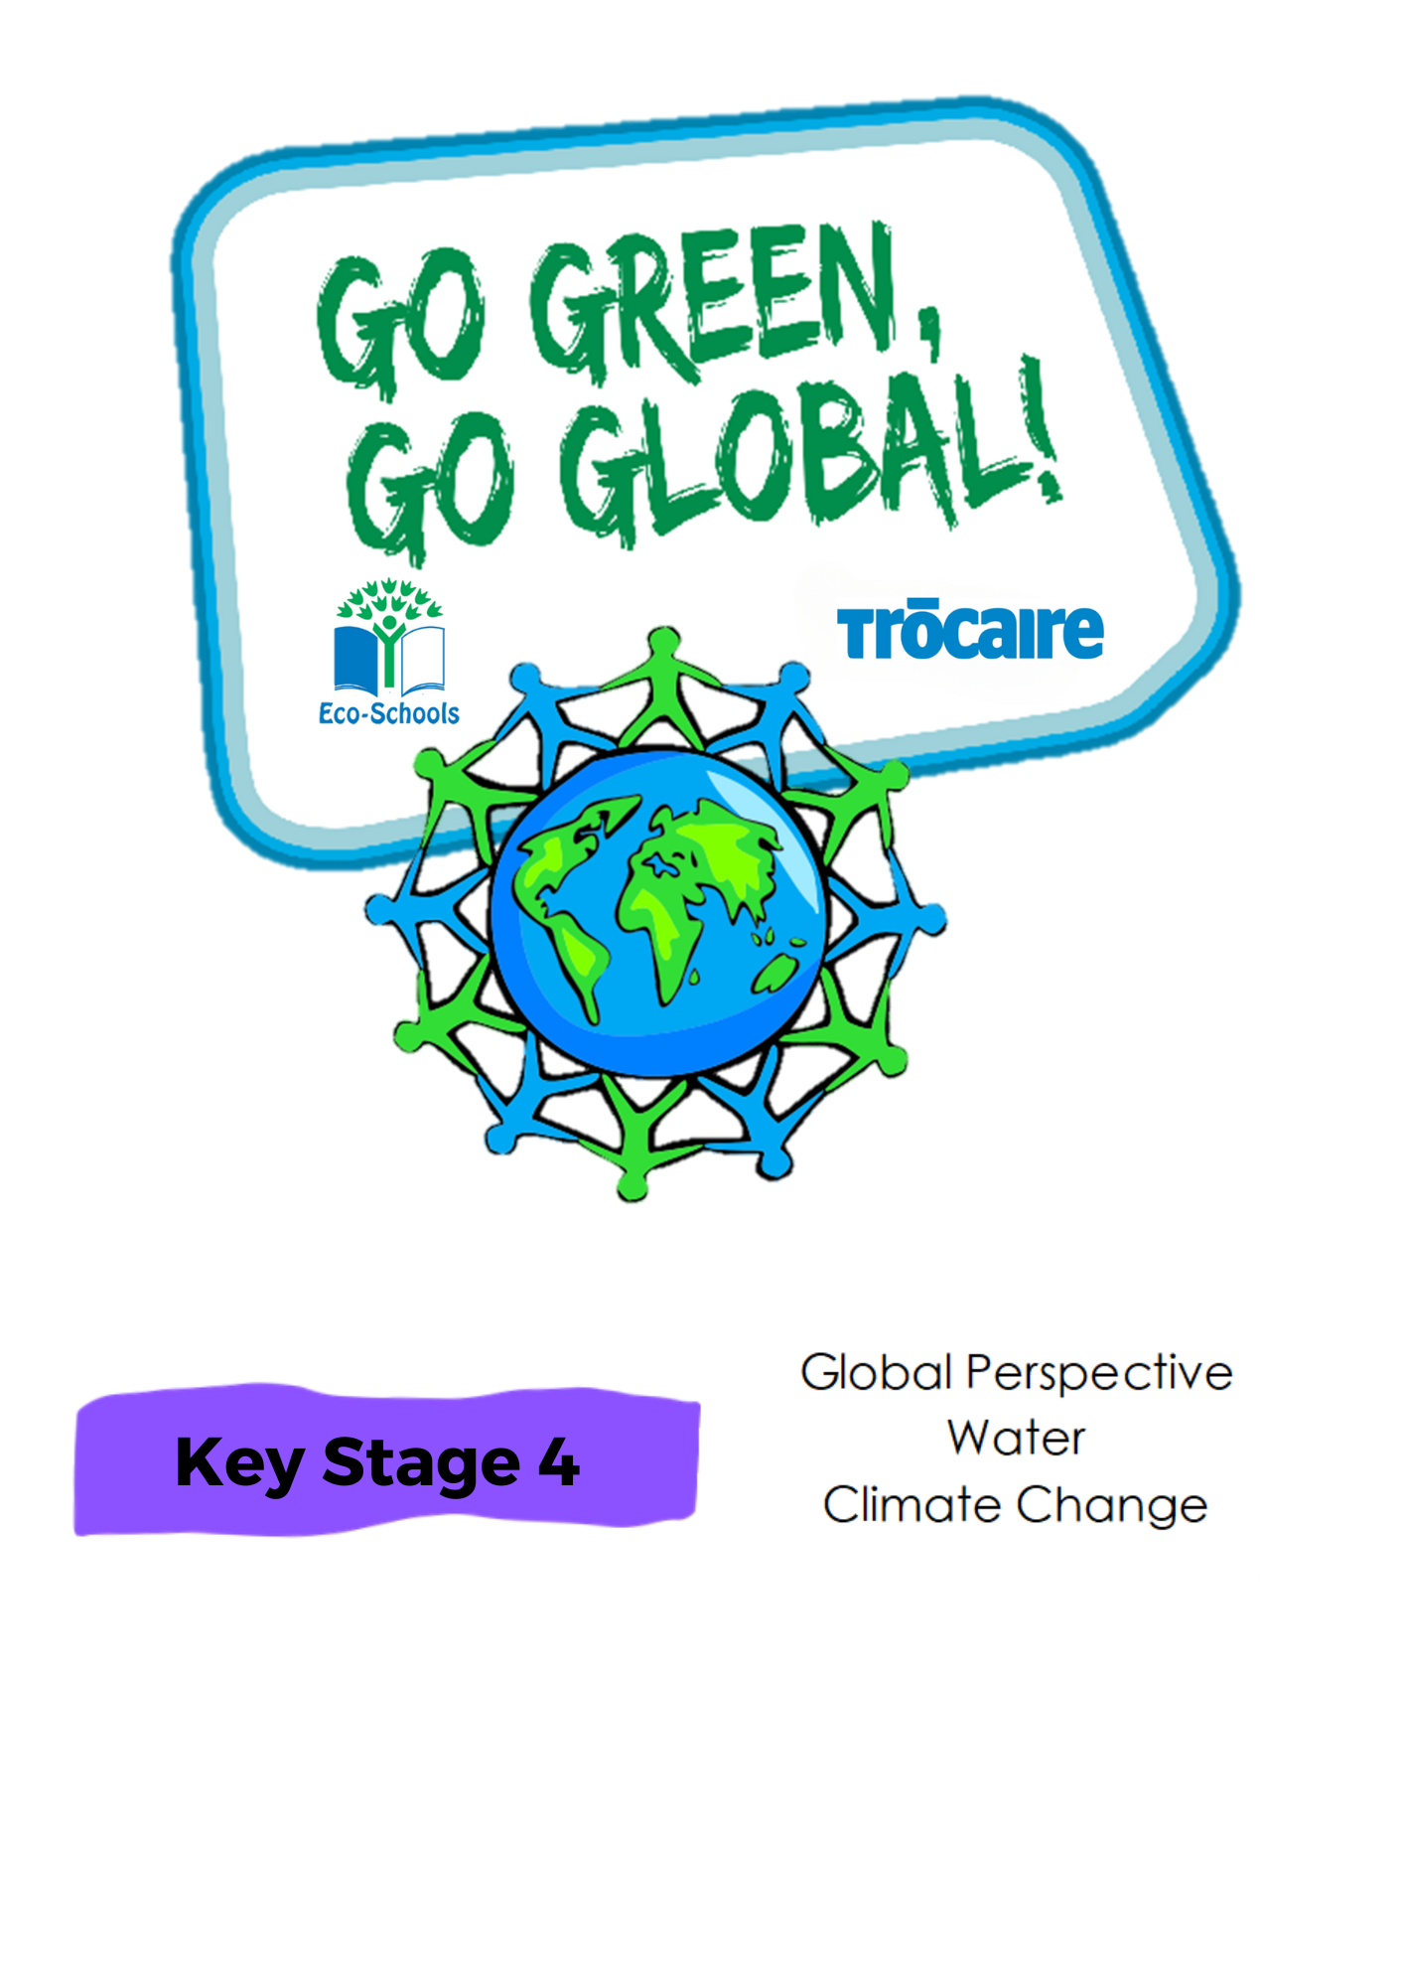

‘Whole Class Activity’ Resource Booklet

The purpose of this resource

The Eco-Schools programme in Northern Ireland is operated by Keep Northern Ireland Beautiful and addresses the following eleven topics within schools:

Biodiversity Energy Global Perspective Healthy Living

Litter Marine Transport Waste

Water Climate Action School Grounds (outdoor learning)

In order to qualify for the much acclaimed 'Green Flag' award level, schools must have shown substantial progress towards completing 'one large scale project topic and indicated involvement with two others'.

Through the expertise of the Irish development agency Trócaire, this resource provides a range of activities to incorporate a global perspective into the classroom. It will focus on three of the eleven Eco-School topics and will explain how to introduce and explore these global issues with your pupils.

Each section contains an information sheet on the global issue and one whole class activity.

**Content**

**Section 1 – Global Perspective** **3-14**

**Section 2 – Water 15 -18**

**Section 3 – Climate Action 19**

Section 1: Global Perspective

**Background information**

**Global Perspective**

The global dimension explores our connections with the rest of the world. With a global dimension to their education, learners can engage with complex global issues and explore the links between their own lives and people, places and issues throughout the world.

The global dimension can inform the whole school ethos, leading to a school that is inclusive, just and democratic and promotes social and environmental responsibility, respect and co-operation.

Citizenship, in its context of fair decision-making, runs throughout the Eco-Schools process. The global perspective topic seeks to ensure that pupils consider the environmental, social and economic impacts of the decisions that they make through this process, on the local and global community, in the future as well as for the present.

**Global Citizenship**

Being a global citizen is not clearly defined, as there is no global government there are no clear rules and regulations and globally, we do not have democratically elected representatives to speak for us.

Global citizenship is more a **moral understanding** of our **responsibilities** and **our rights** in a global context. Being a true global citizen means that we recognise that all people have equal rights and that we value diversity.

In addition, it means we should value the earth as our common home which we all have a need and indeed a responsibility, to look after.

**The Global Environment**

The term **environment** means surroundings or the conditions in which a person lives. However, it can be narrowly defined. For example our immediate surroundings as in the classroom environment or very broadly, in relation to the global environment.

One thing that is certain is that ‘humankind’ has had a huge impact on the environment. Today, many of us have acquired so many things that we have a very comfortable life. But at what cost?

The more that people take from the environment, the more they change the pattern of nature. If we take too much, we risk upsetting this balance.

The balance of nature changes slowly over time but in recent years we have wanted more and more for ourselves, and we are upsetting the balance at a faster rate, without even realising it.

We are part of the natural environment and must look after it. If we upset the pattern too much, we may even destroy ourselves and the lives of future generations.

Trócaire’s focus is on ensuring that our global resources are shared equitably and those in power act for the common good of all.

**Global Population**

Our precious finite world is currently home to over 7.8 billion people. Numbers this big are difficult to understand but what if we imagined the whole population of the world as a village of just 100 people? In this imaginary village, each person would represent about 78 million people from the real world. One hundred people would fit nicely into a small village. By learning about the villagers – who they are and how they live – perhaps we can find out more about our neighbours in the real world and the problems our planet may face in the future.

Imagining the world as a village also makes it easier for us to start thinking about all the human and environmental problems in the world and what we can do about them. It makes it easier for children to grasp the concept that the world is a large place, and many people in the world live lives much different from our own.

**Global Food**

There is plenty of food in the world to feed everybody.

The problem is how this food is distributed and shared.

In fact, more than one and a half times the amount of food needed to feed everybody in the world is produced each year**.**

But over 821 million or 1 in 9 people, go hungry.

If there’s enough food in the world, why do some people still go hungry?

Hunger is caused by many factors and must be solved with many approaches. Factors include lack of investment in small farmers, particular women, unfair international trade policies and climate change.

**Exercise 1: Is the world’s wealth divided equally?**

***Aim:*** To become aware of the inequity of the Global Economy

**Step 1:** Group discussion around how global finances are divided up

**Step 2:** Possible questions to help the discussion:

* Is the money shared equally?
* Are there any figures which shock you and why?

**Exercise 2: If the world were 100 people**

***Aim:*** To grasp the concept that the world is a large place; and many people in the world live lives much different from our own. To look at our relationship with the wider world.

***Materials:*** Internet connection to play the video, photocopies of the worksheet and pens

**Step 1:** Watch the internet video as a class.

**Step 2:**Give pupils the worksheet and in pairs or small groups ask them to fill in the blanks. See below for correct answers.

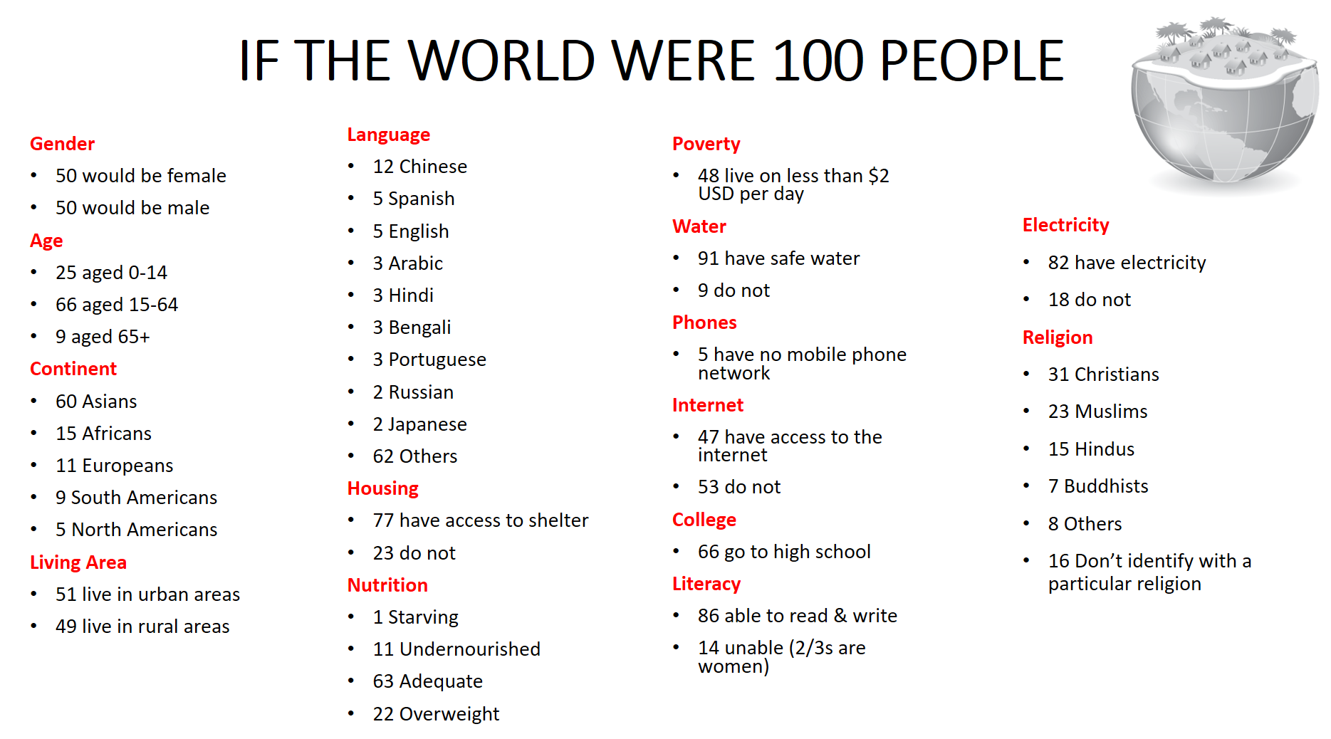

Using the following numbers fill in the blanks. The first one has been completed for you. Remember to circle them once you have used them.

|  |  |  |  |  |  |  |  |
| --- | --- | --- | --- | --- | --- | --- | --- |
| 60 | 12 | 23 | 15 | 11 |  | 47 | 0 |
| 16 | 14 | 5 | 12 | 18 |  | 50 | 15 |
| 5 | 50 | 23 | 31 | 5 |  | 9 | 3 |



60

Asians

Africans

Europeans

are from South America, Central America (including Mexico and the Caribbean)

are from Canada and United States

are from Oceania (Australia, New Zealand, Islands of South, West, Central Pacific)

Males Females

speak English speak Chinese dialect speak Hindi speak Spanish

are Christian are Muslim are Hindi don’t identify

people do not have enough food to eat

have access to the internet

do not have access to shelter

do not have access to electricity

are unable to read or write

**Exercise 3: Lets Debate**

***Aim:*** to carry out a formal debate around the environmental moots suggested to ensure the young people have a Global Perspective

***Materials:*** Formal debate guidelines sheets, speaking orders and times, score sheet

**Step 1:** Read through and discuss the guidelines for a formal debate with the class.

**Step 2:** Pupils arrange themselves into groups of three.

**Step 3:** Moot is picked, and coin toss decides which team are affirmative or negative.

**Formal Debates**

A formal debate is an organised, competitive argument. Formal debates are judged by an adjudicator (like an umpire) who ultimately decides which side wins and which sides loses.

**Debating Roles:**

* **Chairperson**: They introduce the teams, state the moot (topic to be argued) and must keep time & order!
* **Adjudicator**: They watch the debate and give each speaker a score based on what they say (arguments), how they say it (delivery) and how well they demolish the other team (rebuttal). At the end of the debate, scores are combined to reveal which team won.
* **Affirmative Team**: Made up of three team members.
* **Negative Team**: Made up of three team members.
* **The Audience**: They are the people the debaters are trying to persuade so their role is vital!
* **The Moot**: This is the topic to be debated. The moot always begins with the word *“that...”* for example *“That boys are better than girls”.*

**Debating in Six Easy Steps**

**Step One: The Moot**

Your teacher will have a selection of moots around Global Perspective.

**Step Two: The Teams**

Next, we arrange ourselves into teams of three. Teams can request the moot they’d like to argue. However, you will NOT yet know if you are affirmative or negative.

Begin by preparing arguments for BOTH sides of your moot. That way you will have counter-arguments ready to go BEFORE the debate. Be prepared to demolish the other team!

Debating teams need a range of skills, so it will probably NOT be a good idea to work with your friends.

* **First speakers** must be organised, commanding, and have a real presence. They set the tone for the entire debate.
* **Second speakers** must be persuasive and logical, presenting well researched, persuasive arguments to the audience. Some rebuttal is needed here.
* **Third speakers** must be able to think on their feet; their speech will be mostly written DURING the debate. They challenge the other team and try to demolish their arguments.

**Step Three: The Coin Toss**

Teams meet up (on neutral territory) to see which position (Affirmative or Negative) they will be taking in the debate. Good debates are based on good arguments not on personal feelings, be prepared to argue EITHER side. The adjudicator will ask first speakers to ‘call’ and results are final.

**Step Four: Planning, Preparation & Strategy**

Teams will have a few days to plan, prepare, strategize, write and learn their arguments. During the debates, SMALL note cards may be used, but speaking away from your notes always gets you MORE points.

The objective in a debate is to build your team’s arguments strongly and persuasively. At the same time, you are also trying to knock down the other team’s arguments. Imagine **two sandcastles** (built out of good arguments and persuasion), make yours as big as you can and keep trying to kick the other team’s over!



Research, plan and write GOOD arguments but also try to counter-argue anything that the other team might come up with!

Strategy is vital! Your team must have a plan for the day. During your debate, you must write your rebuttal. This means you need to think on your feet and write fast! This is where you really have to TRUST your team!

**Step Five: The Debate**

During the debate, each team member speaks in turn (speaking order & times below).

There are very strict time-limits so you must prepare and present succinct (short and to-the-point), persuasive arguments. You will hear ‘half way’ and ’30 second’ warnings during your speech. When the time is up, you must sit down.

As well as presenting prepared arguments, you must write and present rebuttal DURING the debate. Make sure you have pens and paper so you can make notes for your teammates WHILE the other team is speaking. You cannot talk, so write everything down.

Rebuttal notes should be written by all team members and handed to the next speaker.

Half of the debate is about counteracting the other team’s arguments so, during their speeches, ask yourself:

* What could be wrong with that fact?
* Are there any holes in that argument?
* How can I make that sound awful? *(Without sounding like I’m insane)*
* What have they forgotten to say?
* How can I present this so that it makes them look unreliable, dishonest or deluded?
* How can I get the audience on our side?

**Step Six: The Evaluation**

Evaluate how you and your team did during your debate. You should be honest and specific, aim to highlight areas that you would like to work on to improve for next time.

**Curriculum links**

This can be set as a Speaking & Listening assessments for English Language. It counts for English Language, Unit Two: “Presenting”.

Debate Moots & Teams

|  |  |  |  |
| --- | --- | --- | --- |
| Moot One: |  | | |
| Chairperson: |  | | |
| Affirmative Team: 10 |  | Negative Team: 10 |  |
|  | | | |
| Moot Two: |  | | |
| Chairperson: |  | | |
| Affirmative Team: 10 |  | Negative Team: 10 |  |
|  | | | |
| Moot Three: |  | | |
| Chairperson: |  | | |
| Affirmative Team: 10 |  | Negative Team: 10 |  |
|  | | | |
| Moot Four: |  | | |
| Chairperson: |  | | |
| Affirmative Team: 10 |  | Negative Team: 10 |  |
|  | | | |
| Moot Five: |  | | |
| Chairperson: |  | | |
| Affirmative Team: 10 |  | Negative Team: 10 |  |
|  | | | |
| Moot Six: |  | | |
| Chairperson: |  | | |
| Affirmative Team: 10 |  | Negative Team: 10 |  |
|  | | | |
| Moot Seven: |  | | |
| Chairperson: |  | | |
| Affirmative Team: 10 |  | Negative Team: 10 |  |

Speaking Order & Times

|  |  |  |
| --- | --- | --- |
| **1** | **Chairperson**  **1 minute** | Welcomes audience, teams & adjudicators then introduces the moot. We are here today to debate the moot “*That....”* |
| **2** | **First Affirmative**  **3 min** | Introduce and define moot, explain team line up and argument split. Present your team’s position on the moot (in the best possible light), pre-empt negative team’s position (in worst possible light) or N1’s opening if possible. Present 1-2 good arguments. |
| **3** | **First Negative**  **3 min** | Agree or disagree with A1’s definition of moot, define affirmative team’s position (in worst possible light) define your team’s position (in best possible light). Challenge any points raised by A1. |
| **4** | **Second Affirmative**  **3min** | Present rebuttal against N1’s opening arguments.  Arguments, arguments, arguments. Present a series of well developed, persuasive arguments FOR the moot. |
| **5** | **Second Negative**  **3min** | Present rebuttal against A2’s opening arguments.  Arguments, arguments, arguments. Present a series of 3-6 well developed, persuasive arguments AGAINST the moot. |
| **6** | **Third Affirmative**  **3min** | Present rebuttal against N2’s arguments. Tries to destabilise the negative team’s entire position.  Presents 1-2 new arguments (if there’s time). |
| **7** | **Third Negative**  **3min** | Present rebuttal against N2’s arguments. Tries to destabilise the affirmative team’s entire position.  Presents 1-2 new arguments (if there’s time). |
| **8** | **First Negative**  **1min 30 sec** | Right of Reply: No new arguments!   * Final rebuttal, then restate the moot and your team’s position. * Point out why the opposing team should not win. * Argue why your position is the best and most logical (or helpful) for the audience. Explain why you should win. |
| **9** | **First Affirmative**  **1min 30sec** | Right of Reply: No new arguments!   * Final rebuttal, then restate the moot and your team’s position. * Point out why the opposing team should not win. * Argue why your position is the best and most logical (or helpful) for the audience. Explain why you should win. |

Each debate takes 25 minutes from start to finish. In order to get through two debates in each lesson, we will need to be early to class and QUICK setting up!

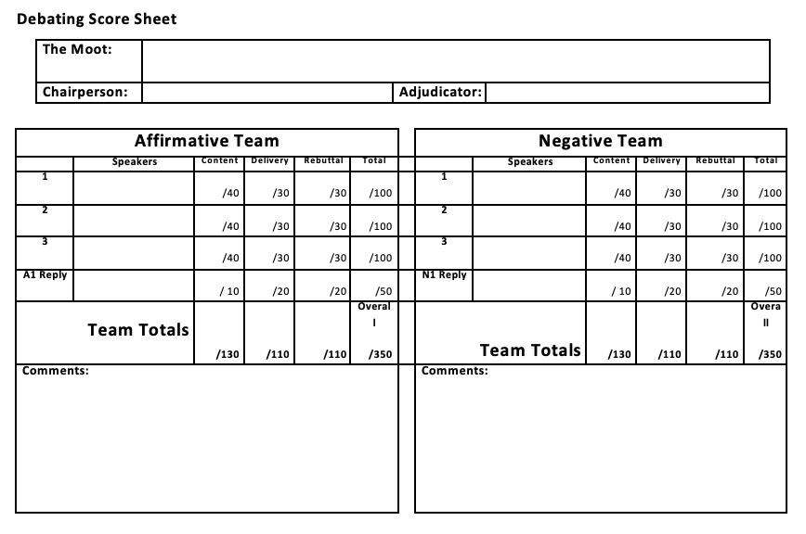

Section 2: Water

**Background information**

Water is an extremely important natural resource in our everyday lives. Our bodies are 70% water, without it we would die within 3 days. The Earth is also 70% water, however, only 2.5% of it is fresh water. Moreover, only 1% is easily accessible to us as most of it is trapped in glaciers.

Living in Northern Ireland, we are often unaware of the current water crisis that exists in our world. We simply turn a tap to get water. Contrastingly, many women in Africa and Asia walk on average 6 Miles a day to collect water. Furthermore, one sixth of the world's population lacks access to safe water and 40% lack adequate sanitation. With a growing population, demand for water resources increases.

A lack of water supply can have a severe impact on education levels and health among the population.

**Exercise: Mapping of water scarcity**

***Aim:*** To identify which areas of the world are currently facing water scarcity and find correlations between water, health, and academic levels within a region

***Material needed:*** 2 worksheets, colouring pencils (preferably green, blue, and red)

**Step 1:**Use the table to complete the water scarcity world map. Discuss the percentage of the world which faces no water issues today. Are you shocked at this figure?

**Step 2:**In groups of 3/4 students, compare the three world maps.

**Step 3:**Present your findings to the class and discuss how water scarcity (physical, economic, or abundant) can have an impact on the population's quality of life, in terms of health and education.

**Video link**: attached to PowerPoint.

|  |  |
| --- | --- |
| **Region** | **Description of water scarcity** |
| Northern America | North America experiences little or no water scarcity, with the exception of the southwest area, which can be quite dry and barren. |
| Central and South America | Both Central America and South America suffer largely from economic water scarcity. |
| The Caribbean | The Caribbean has little or no water scarcity. |
| Europe | Aside from local or seasonal water issues, the continent of Europe has no significant water scarcity in any of its regions. |
| Western Asia | Physical water scarcity is experienced in all countries within Western Asia, with the exception of Turkey, which suffers from economic water scarcity. |
| Central and Southern Asia | Central and Southern Asia struggle because of physical water scarcity. Southern coastal regions of India face economic water scarcity. |
| Eastern Asia | Northern regions of China suffer from physical water scarcity, while the rest faces economic water scarcity. |
| Southeastern Asia | The whole region encounters economic water scarcity. |
| North Africa | Most of Northern Africa has physical water scarcity. |
| Western, Middle and Eastern Africa | These regions suffer from severe economic water scarcity. |
| Southern Africa | The eastern regions of South Africa (Lesotho and Swaziland) encounter economic water scarcity. The rest suffer from physical water scarcity. |
| Australia and New Zealand | Australia has little or no water scarcity, apart from the southeast of Australia which faces physical water scarcity. No water scarcity issues exist in New Zealand. |

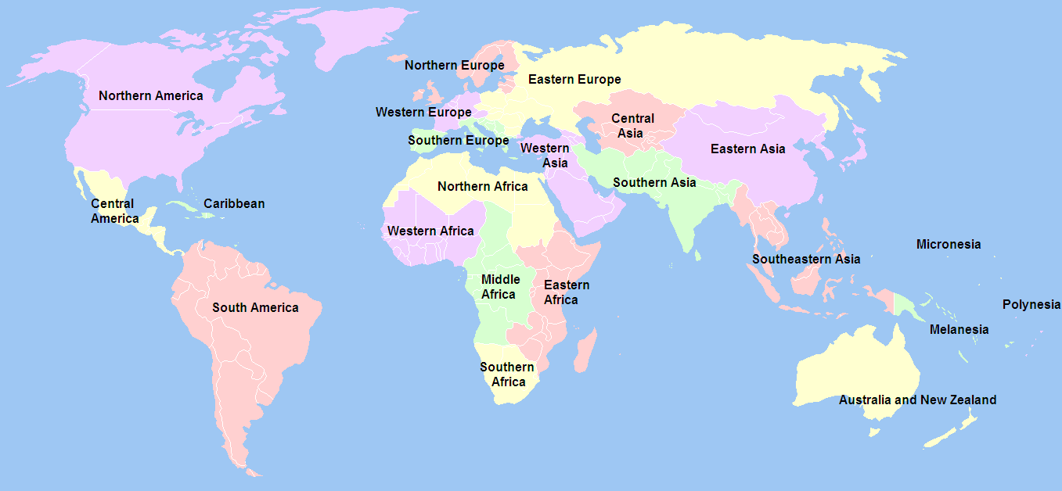

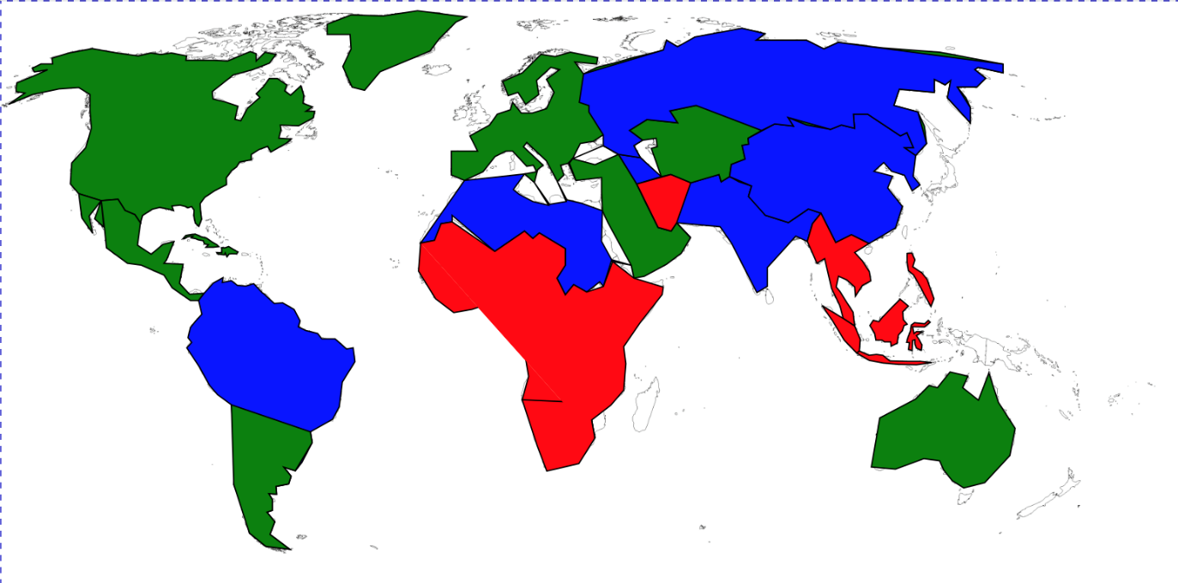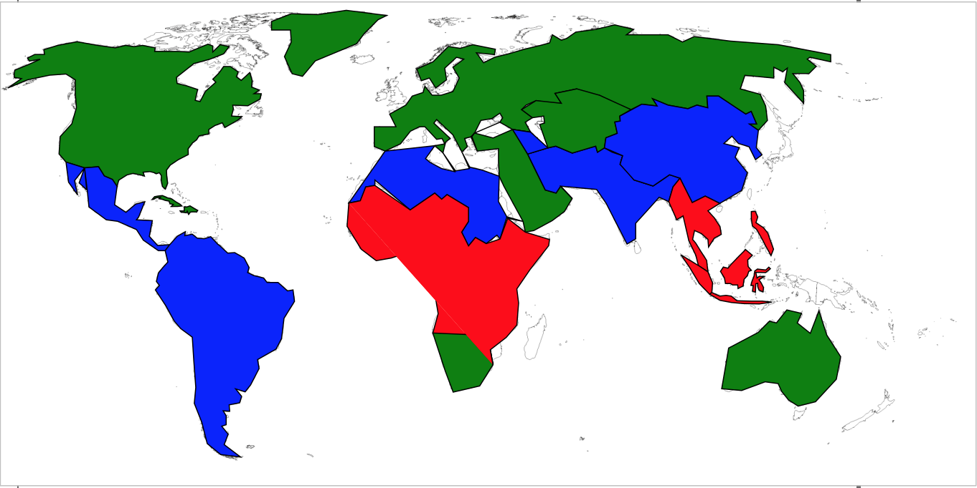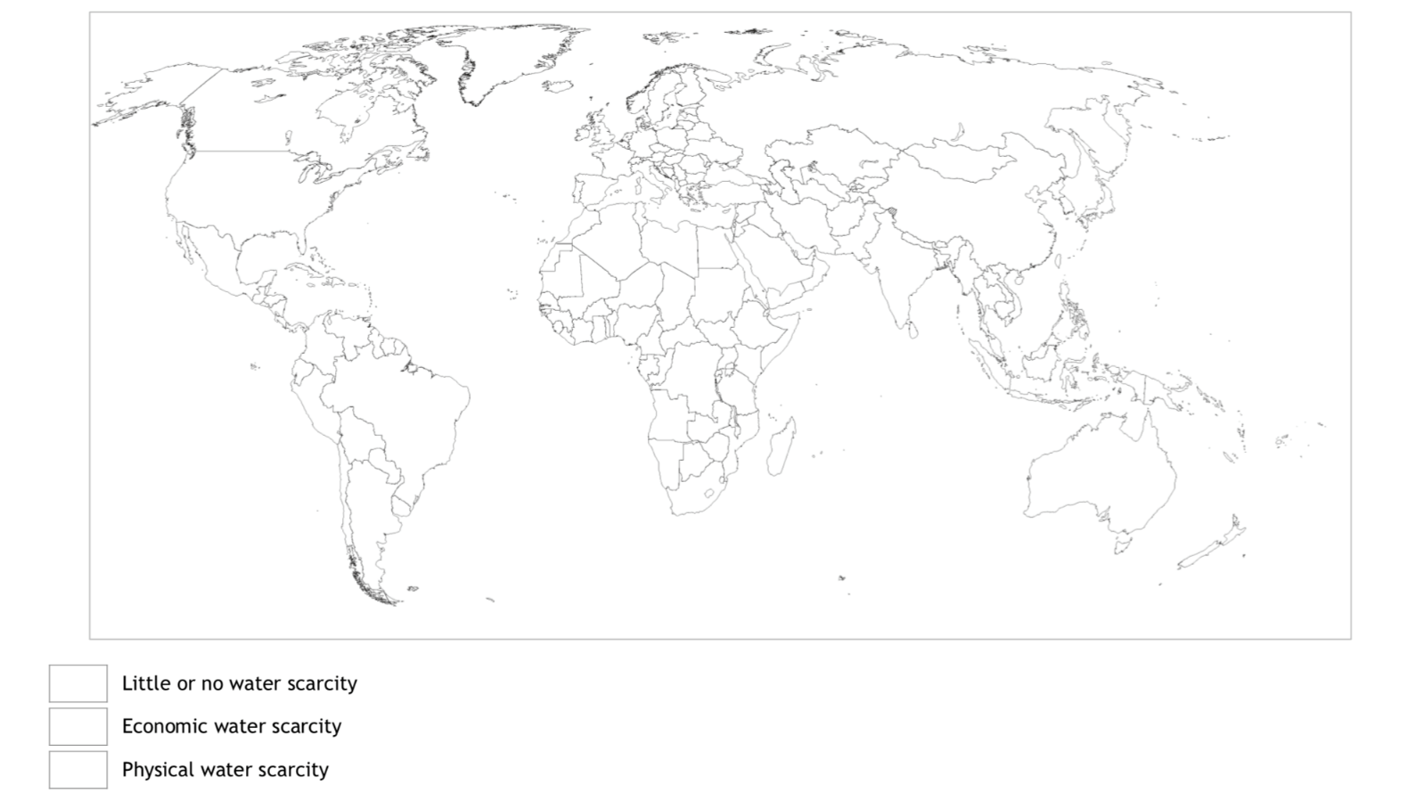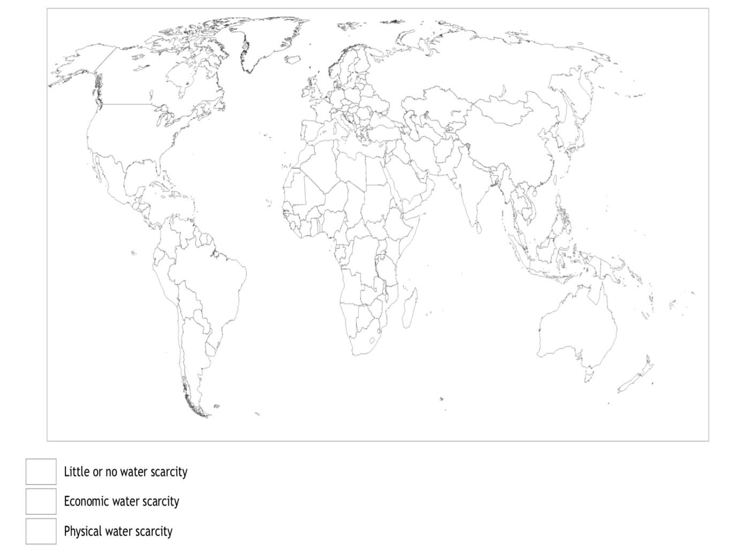

Index:

High academic level

Medium academic level

Low academic level

Index:

Good health levels

Medium health levels

Low health levels

Section 3: Climate Action

**Background information**

Climate change has been a threat for many years now. It has now advanced to robbing people of their livelihood and homes. Climate refugees are present in today’s world. Although people in developing worlds often don’t contribute as much to climate change, they are the ones suffering the most from it. Is this fair?

**Exercise: Climate Refugee**

***Aim:***  to realise that many people was forced to leave their home because of the effects of climate change on their environment.

***Material needed:*** Access to a computer

**Step 1:**Explore what the students already know about climate change. Discuss their contribution to climate change. Question whether climate change has impacted their life. Take a vote on ‘are there currently climate refugees.

**Step 2:**Watch the video on climate refugees of today: <https://www.nytimes.com/2017/03/22/learning/lesson-plans/a-lesson-plan-about-climate-change-and-the-people-already-harmed-by-it.html>.

**Step 3:**After watching the video discuss how climate change has affected Bolivia and its people.

**Step 4:**Discuss whether these people should have the same rights as those escaping from wars?

**Step 5:**Each student must promise to reduce their contribution to climate change in 3 ways. Review these changes at the end of the school year.

**Step 6:**Imagine this was your reality. What would you pack? Where would you go? How would you feel? Create a piece stating your situation, expressing your feeling and desire for people to make a positive change in their lives in regard to reducing the impacts of climate change. Publish the winning piece in the school’s newspaper.