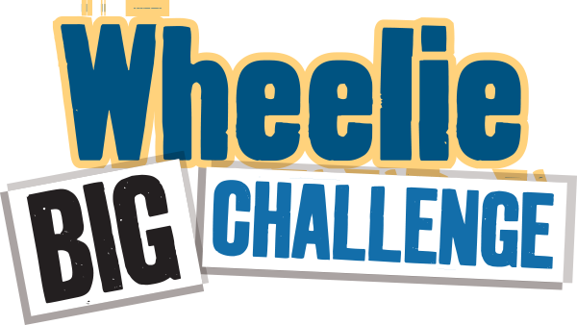

**Worksheet - Waste Audit 2**

**Detailed Audit - What’s happening inside the school?**

**The aim of this task is to find out what is in your waste bins that could be recycled.** Do not weigh recycling bins for this task – although you may want to do that separately. You will need gloves, scales and perhaps a plastic sheet for this activity.

Choose 3-5 small waste bins from a variety of areas (e.g. classrooms, office, ICT room, staff room) towards the end of the day**. Note you will audit the same bins as you did for Audit 1.** Separate each bin into three categories: recyclable, non-recyclable, and food waste. Weigh each (in grams) and record in the chart below. (Remember to save these results in your Data Zone!)

|  |  |  |  |  |
| --- | --- | --- | --- | --- |
|  | **Mixed Dry Recyclables**  (e.g. paper, card, plastic, yoghurt pots, tins)  / **grams** | **Compostable Food**  (e.g. crusts, fruit, teabags)  / **grams** | **Non-Recyclable**  (e.g. wrappers, cling film, pens, straws, tissues)  / **grams** | **Overall weight**  (e.g. everything in the bin)  / **grams** |
| **Bin 1 from:** |  |  |  |  |
| **Bin 2 from:** |  |  |  |  |
| **Bin 3 from:** |  |  |  |  |
| **Bin 4 from:** |  |  |  |  |
| **Bin 5 from:** |  |  |  |  |
| **Total weight** |  |  |  |  |
| **Percentage** | _________% | _________% | _________% | 100% |

Has there been an improvement from waste Audit 1? Dry Recycling % improvement ____________ Food Recycling % improvement ____________

**To complete your bin Audit 2, you can also check your single-use items!**

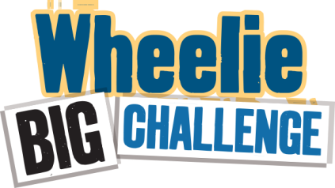From the mixed dry recyclables and the non-recyclable items, select the ones in the table below that are single-use and count how many of each item you can find.

|  |  |  |  |  |  |  |  |  |  |
| --- | --- | --- | --- | --- | --- | --- | --- | --- | --- |
| **Item** | Cups | Cutlery (forks, spoons, stirrers) | Straws | Food packaging | Yogurt Pots | Plastic bottles | Cling film | Plates | Lids |
| **Number** |  |  |  |  |  |  |  |  |  |

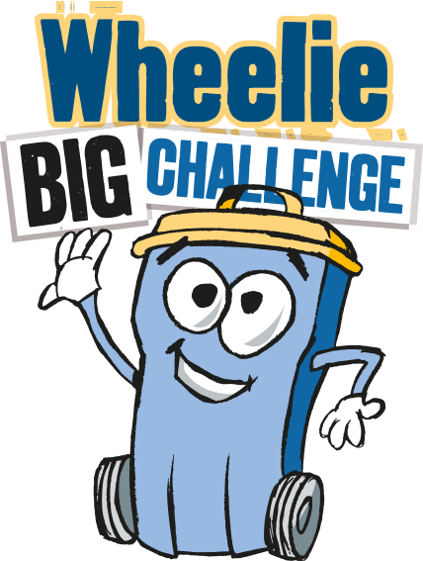**WELL DONE FOR COMMITTING TO REDUCE SINGLE-USE PLASTIC! NOW YOU ARE READY TO UPDATE YOUR PLASTIC PROMISE HERE:** <https://www.liveherelovehere.org/cgi-bin/PlasticPromiseMakeYourPromise>

**Simple Audit - What’s happening outside? Has anything changed from Audit 1?**

**Take a sneak peek.** What’s in the waste/landfill bins? Can you see recyclable items in there? List any that you see:

**Is this an improvement from Audit 1?**

**\*Don’t forget to send your audits and competition entry form to** [**eco-schools@keepnorthernirelandbeautiful.org**](mailto:zara.hamilton@keepnorthernirelandbeautiful.org) **for a chance to win up to £500!**